
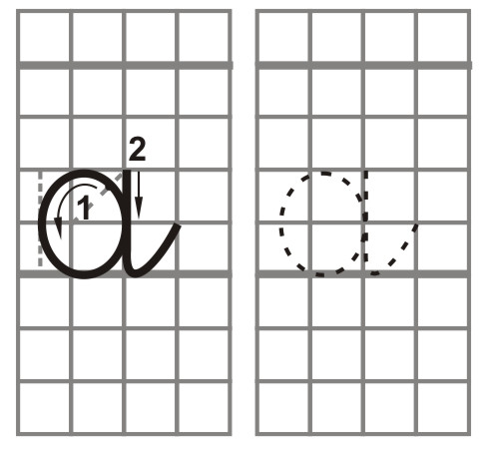
Bài tập viết 1
ngày
tên:
aaaaaaaa

aaaaaaaa
aaaaaaaa
aaaaaaaa
aaaaaaaa
aaaaaaaa
aaaaaaaa
aaaaaaaa
aaaaaaaa
aaaaaaaa
aaaaaaaa
aaaaaaaa
aaaaaaaa
aaaaaaaa
aaaaaaaa
aaaaaaaa
aaaaaaaa
aaaaaaaa
aaaaaaaab

